Tasks on Terraform-03
1) Watch terraform-03 video.

Completed Watching video.

2) Execute the script shown in video.

4) Environmental variables:
--> export TF_VAR_filename="/root.pets.txt"
--> export TF_VAR_prefix= "MR"
--> Set-Item -Path env:TF_VAR_filename -Value 'wild.txt'

These are temporary variables, after session or restart these variables will be collapsed.
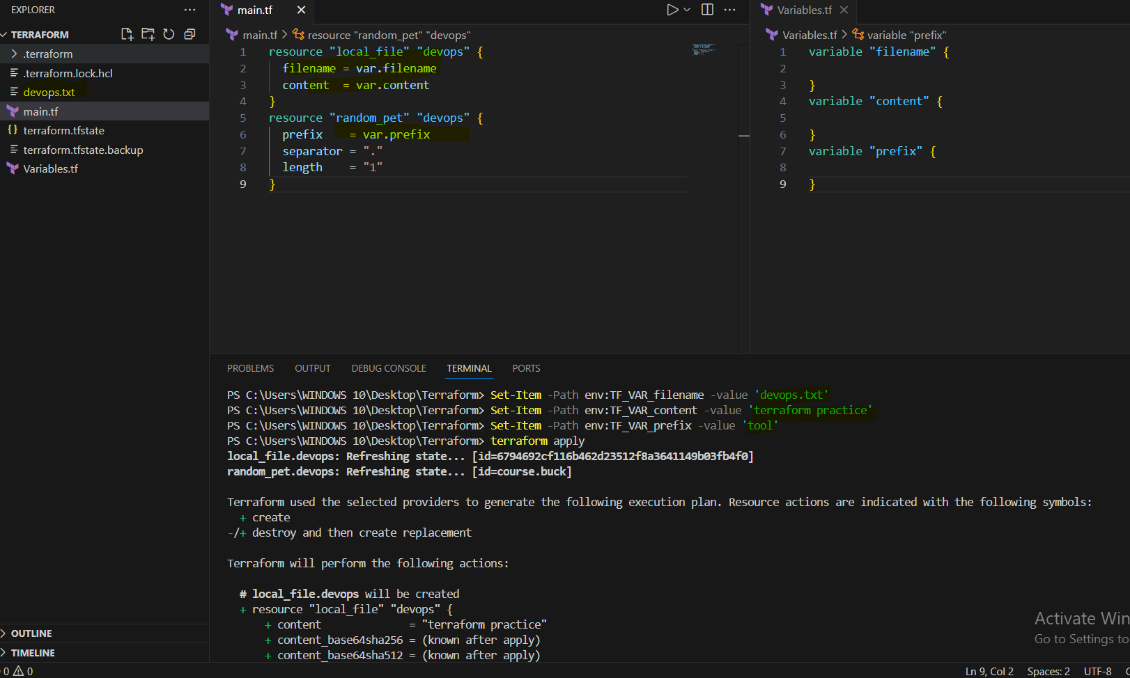
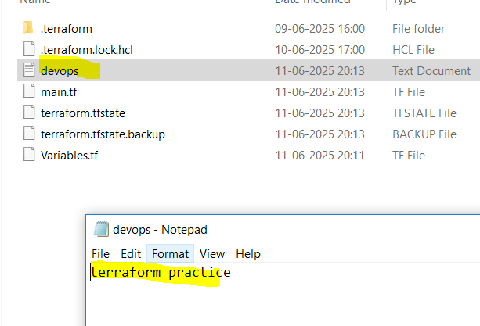
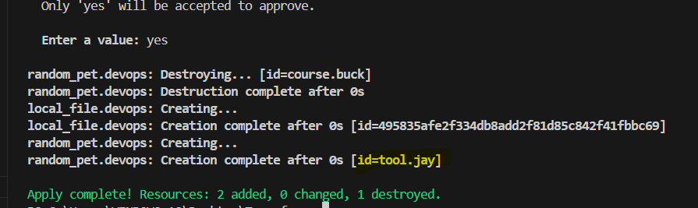

5) Variable definition file:

--> for automatically loaded file name *.auto.tfvars/*.auto.tfvars.json
--> if we are saving the file with other name like varible.tfvars then we need to pass this in CLI
--> terraform apply -var-file varibale.tfvars

The empty varaibles.tf which defines only attributes but not values, values are defined in another file as shown below. By using the command terraform apply -var-file <filename.tfvars> we can execute the template.

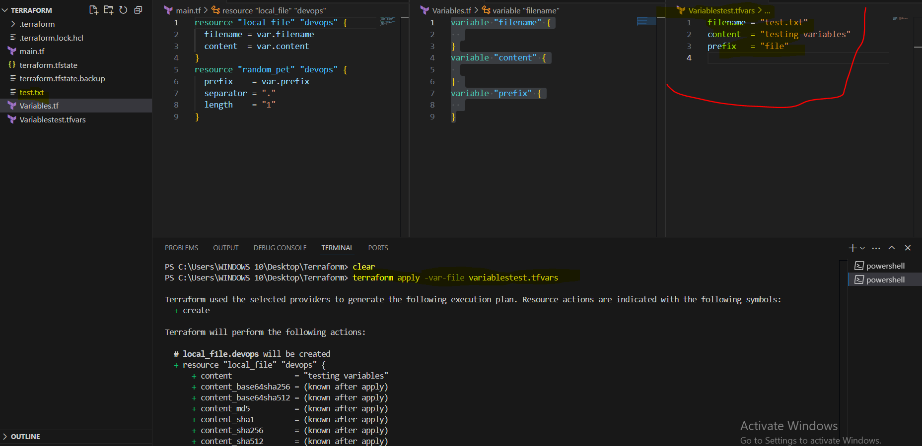

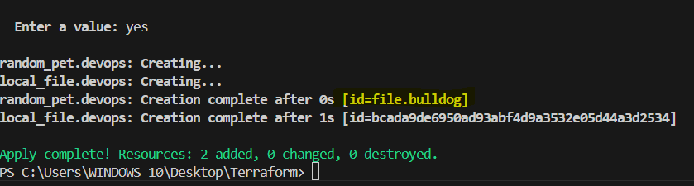
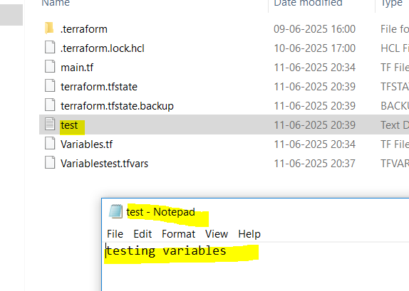

Varible definition precedence:
=============================
If we use multiple ways to define varibles for the same file then terraform uses varible definition precedence

Example:
--> main.tf

resource local_file pet {
filename = var.filename
}

--> variable.tf

variable filename {
type = string
}

--> export TF_VAR_filename="/root/cat.txt"
--> Set-Item -Path env:TF_VAR_filename -Value 'wild.txt'
--> terraform.tfvars
filename = "/root/pets.txt"
--> varible.auto.tfvars
filename = "/root/mypet.txt"

--> terraforma apply -var "filename=/root/best-pet.txt"

Precedence order:
================

in the above example we have passed all the possible varibles,which will terraform laod first and which will override ?

Order Option
1 Environment variables
2 Terraform.tfvars
3 *.auto.tfvars(alphabetical order)

If we are using variables.tf, env variables and CLI flags with different values all at same time, then what will be executed first? That priority is called Precedence order.
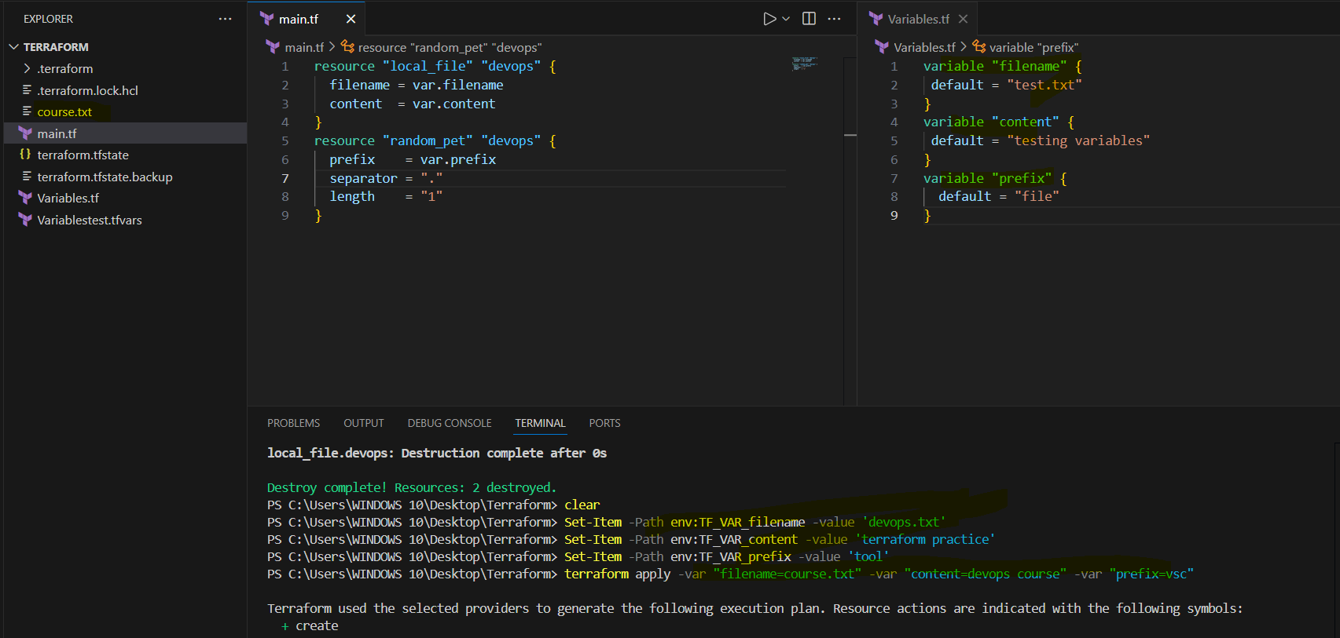
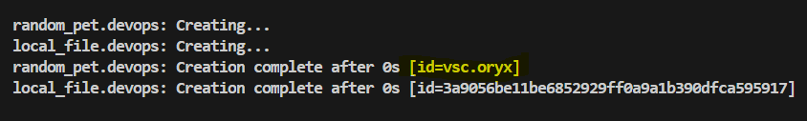

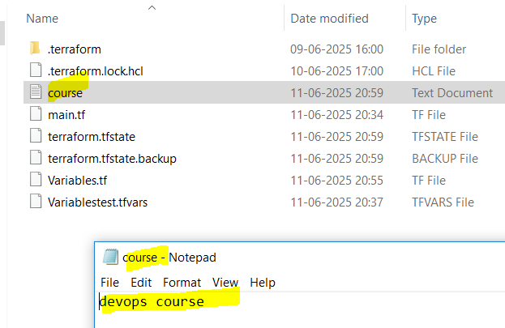
Resource Attribute reference: Implicit dependency
=========================================
If i want to link two resources together by using resource attributes.
Use value from one resource in another

main.tf
======
resource "local_file" "pet" {
filename = "/root/pets.txt"
content = "My cat is MR.Cat"
}
resource "random_pet" "mypet" {
prefix = "MR"
separator = "."
length = "1"
}

When we execute terraform apply it will create random id with pet name,
now i want to add this pet name in my content file (using output of one resource as input for another resource).

main.tf
======
resource "local_file" "pet" {
filename = "/root/pets.txt"
content = "My cat is ${random_pet.mypet.id}" (random_pet = resource type,mypet = resource name, id = attribute)
}
resource "random_pet" "mypet" {
prefix = "MR"
separator = "."
length = "1"
}

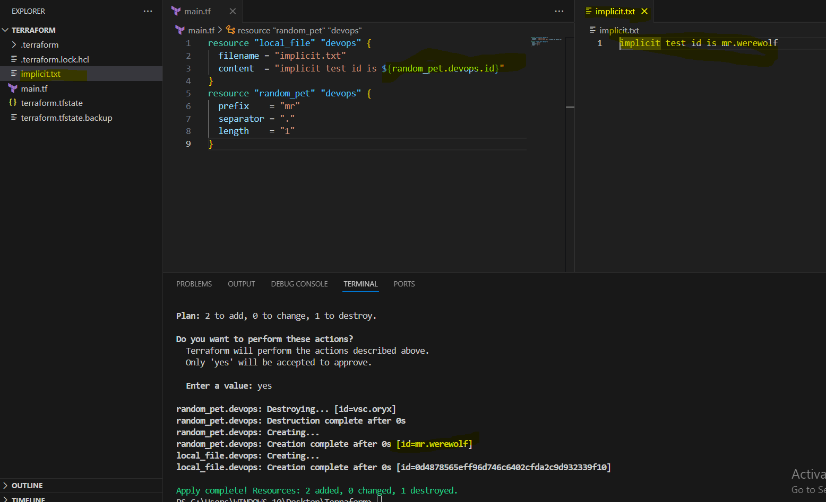

Resource Dependencies: Explicit dependency
======================================

From the above main.tf we have local_file which is dependent on random_pet resource.
We are not mentioning that anywhere but still terraform will figure that out, we call them as implicit dependecy.

Still we can define the dependency explicit by ourself using "depends_on" module
Force resource creation order

resource "local_file" "pet" {
filename = "/root/pets.txt"
content = "My cat is ${random_pet.mypet.id}""
depends_on = [
random_pet.mypet
]
}
resource "random_pet" "mypet" {
prefix = "MR"
separator = "."
length = "1"
}

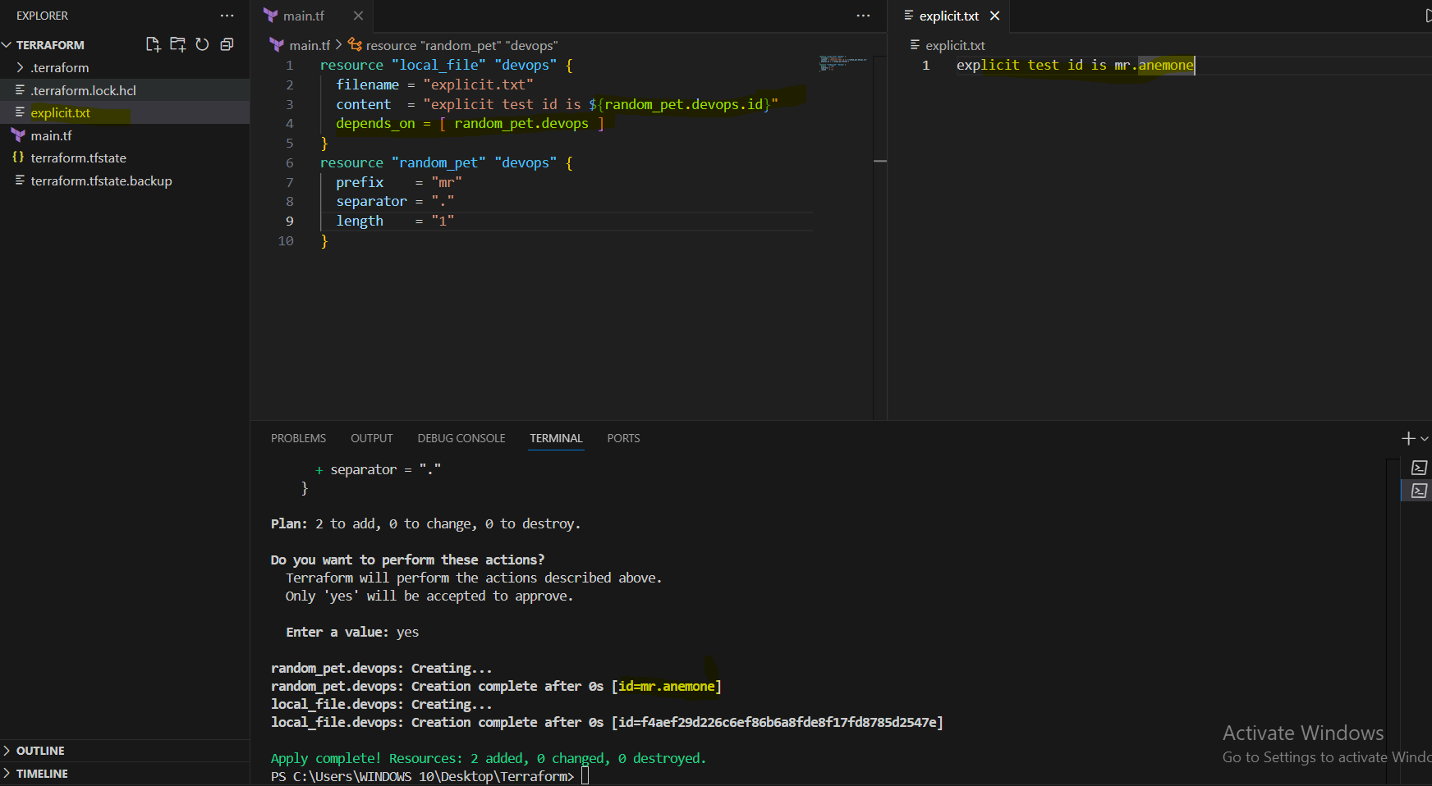

Output variables:
=================
These are used to display the output of the resources.
Ex:
resource "random_pet" "mypet" {
prefix = "MR"
separator = "."
length = "1"
}

output my-pet {
value = random_pet.my-pet.id
description = optional name
}

when we use terraform apply we can see the id as output.
we can use terraform output command to see the output of the resource.

terraform output – helps us to get all the output to the display.

We need to use command terraform apply after adding the output variable.

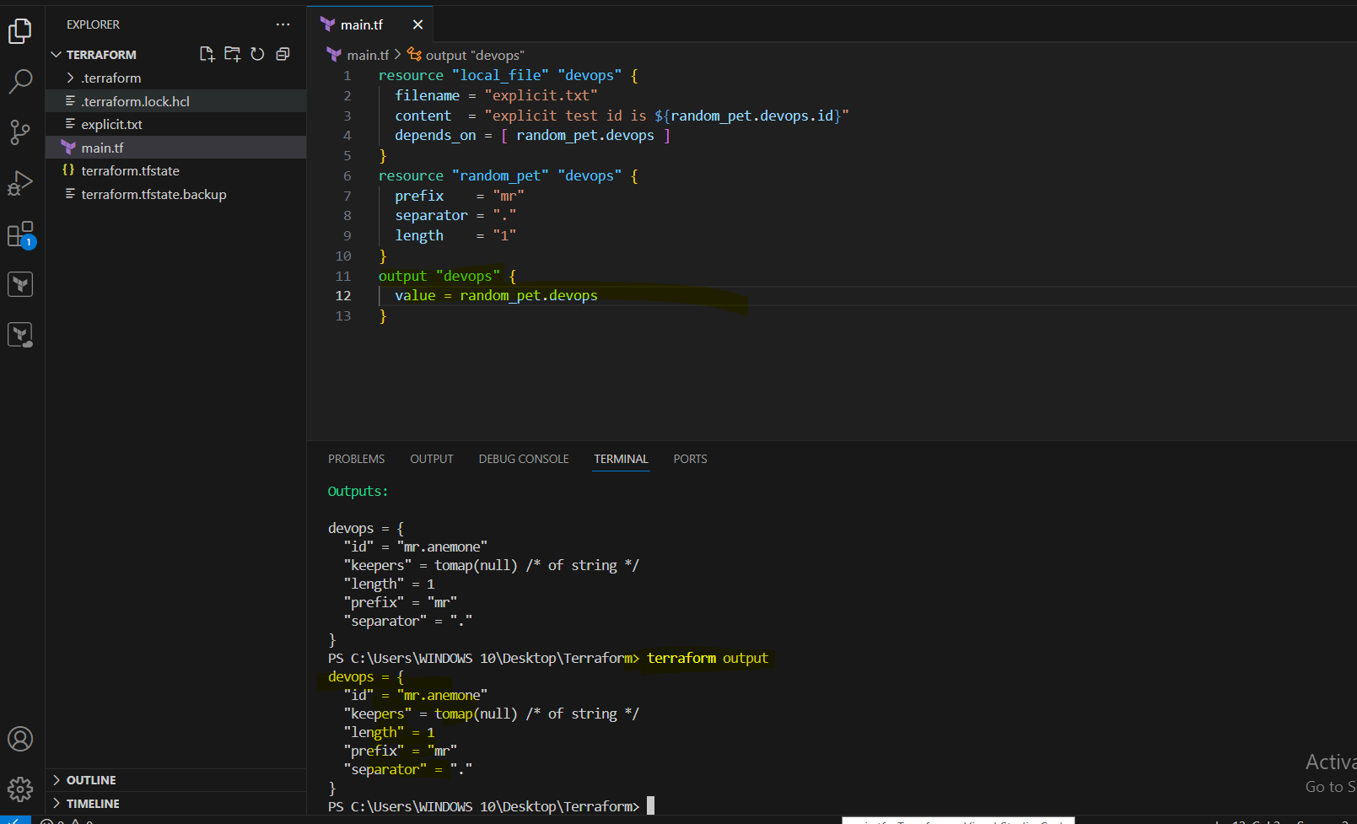

Terraform state:
================
Terraform state file will have the complete record of the infra created by terraform.
State file is considered as a blue print of all the resources terraform manages.
terraform.tfstate will be the name of the file and this will created only after using terraform apply command.

When we excute terraform apply then terraform will check for the state file config and main.tf configuration and make the changes.
If both the files are in sync and we are again trying to execute terraform apply then terraform will not make the changes but show
"Terraform has compared your real infrastructure against your configuration and found no differences, so no changes are needed."

Each resource created by terraform will have the unique ID.
State files also capture the Metadata of the configuration file.
State file will helps for better performance because of the cache of the data.
state file benifits in collborating with different team members.
State files should be shared in the remote backend place so that team can access the state file.
State files also store the sensitive data so not recommended to store in public repo's like github,gitlab.

Terraform state is a json format file,never try to edit the state file manually.

terraform show – it will show whatever is stored in state file terraform.tfstate

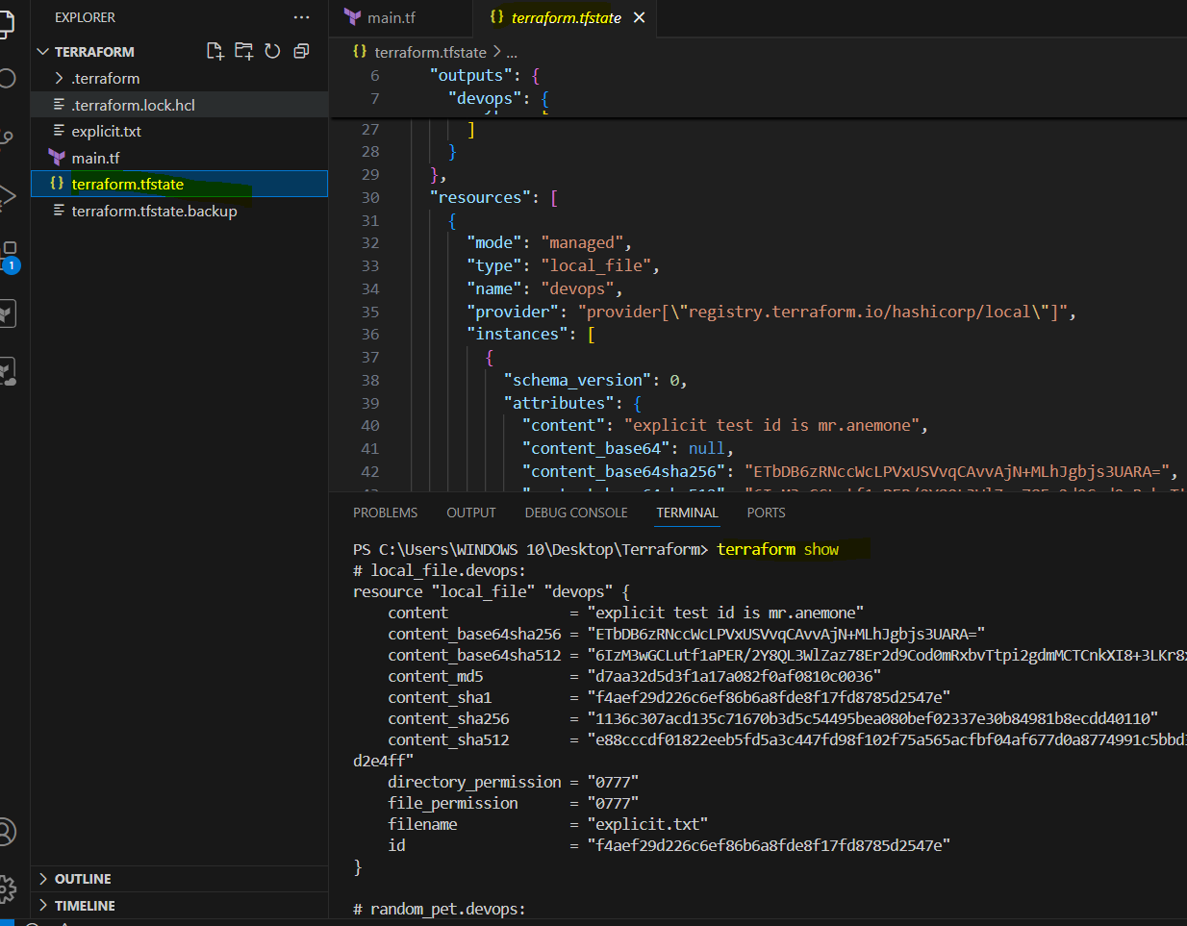

3) Intergrate terrafrom in jenkins using Terraform plugin.

We need to install Terraform plug in our Jenkins.
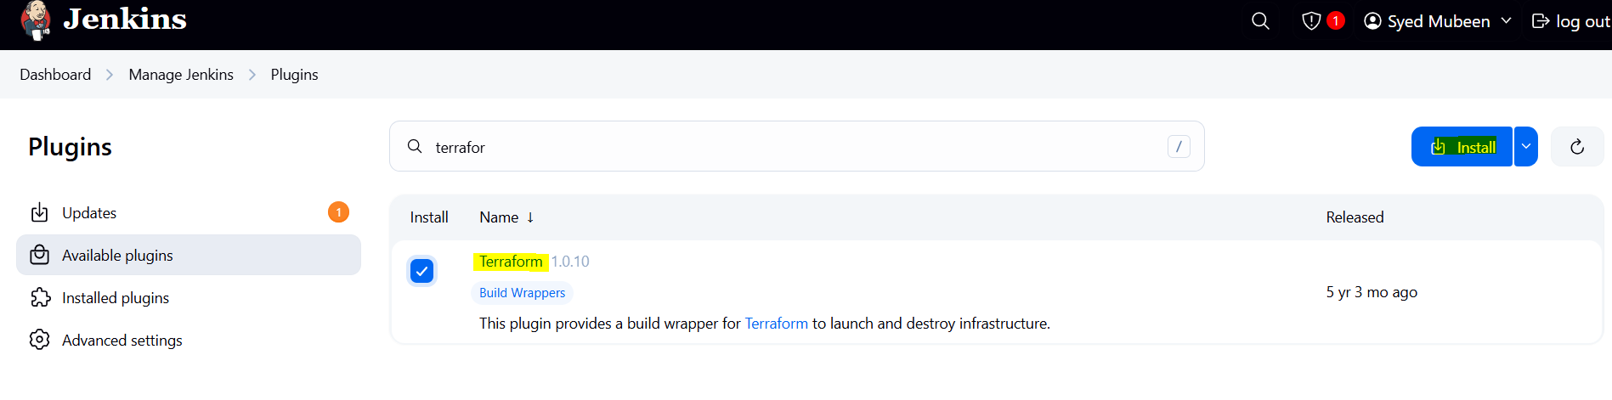

Need to configure Terraform in tools.
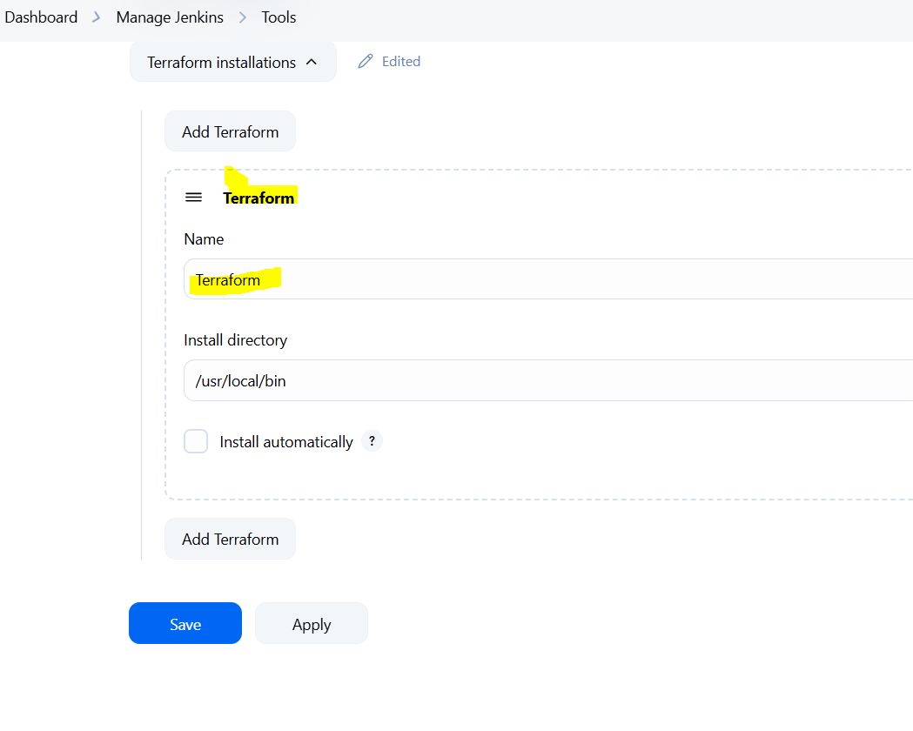

Template in main.tf of the git repo.

resource "local_file" "devops" {
filename = "explicit.txt"
content = "explicit test id is ${random_pet.devops.id}"
depends_on = [ random_pet.devops ]
}
resource "random_pet" "devops" {
prefix = "mr"
separator = "."
length = "1"
}
output "devops" {
value = random_pet.devops
}

Create a job with name Terraform.
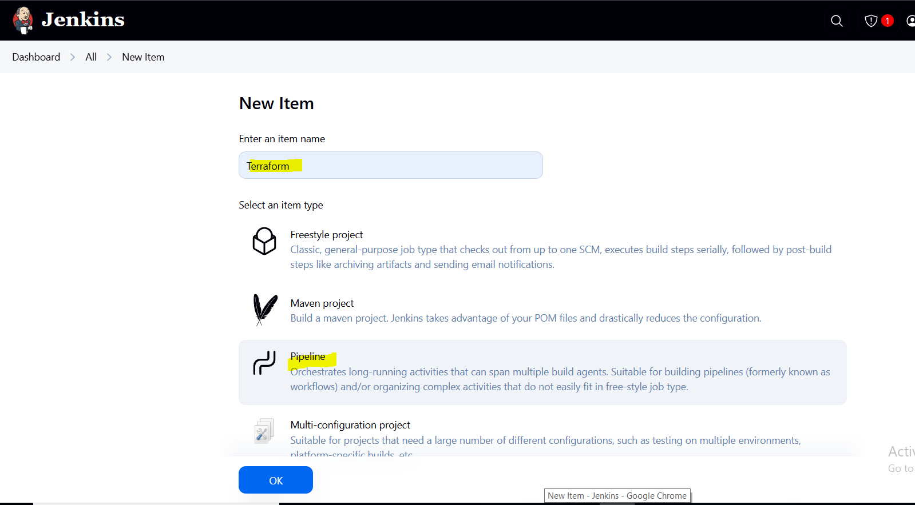
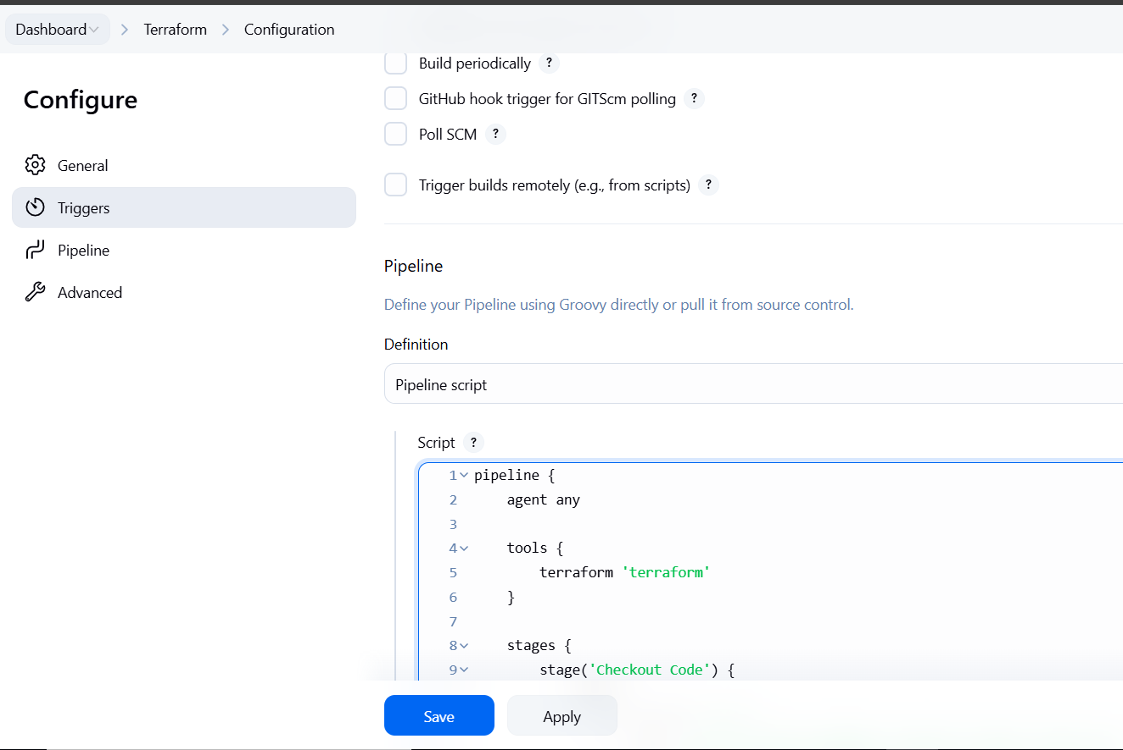

Pipeline used:
pipeline {
agent any

tools {
terraform 'Terraform'
}

stages {
stage('Checkout Code') {
steps {
git branch: 'main',
url: 'https://github.com/mubeen-hub78/terraform-jenkins.git'
}
}
stage('Terraform Init') {
steps {
sh 'terraform init'
}
}
stage('Terraform Apply') {
steps {
sh 'terraform apply -auto-approve'
}
}
}
}

Now run the job.

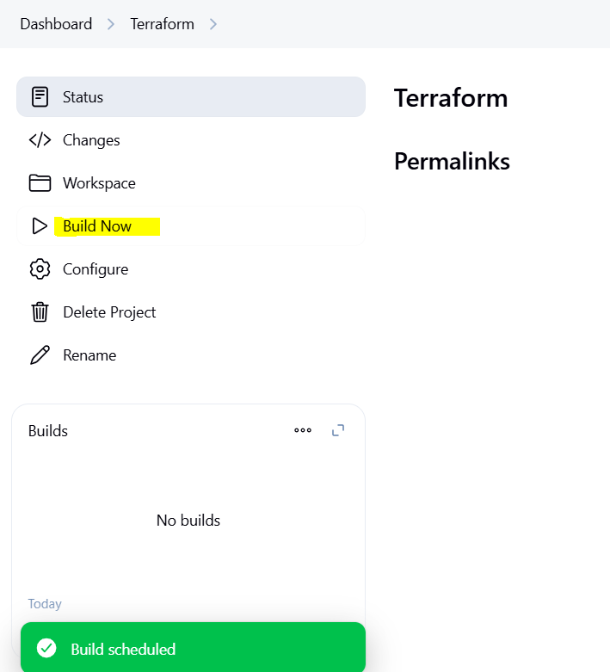

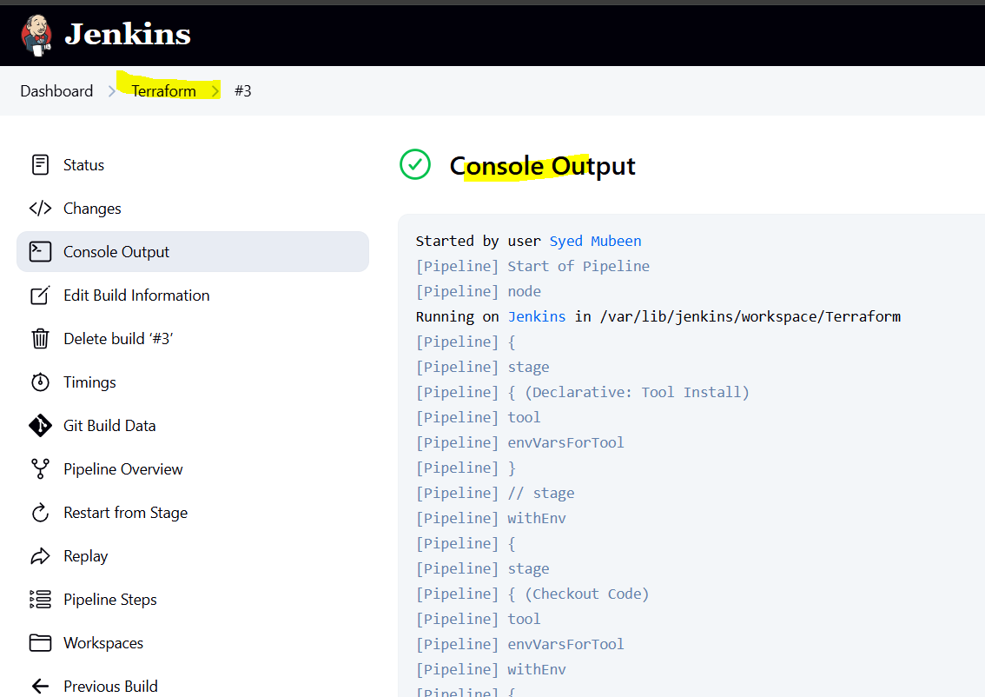

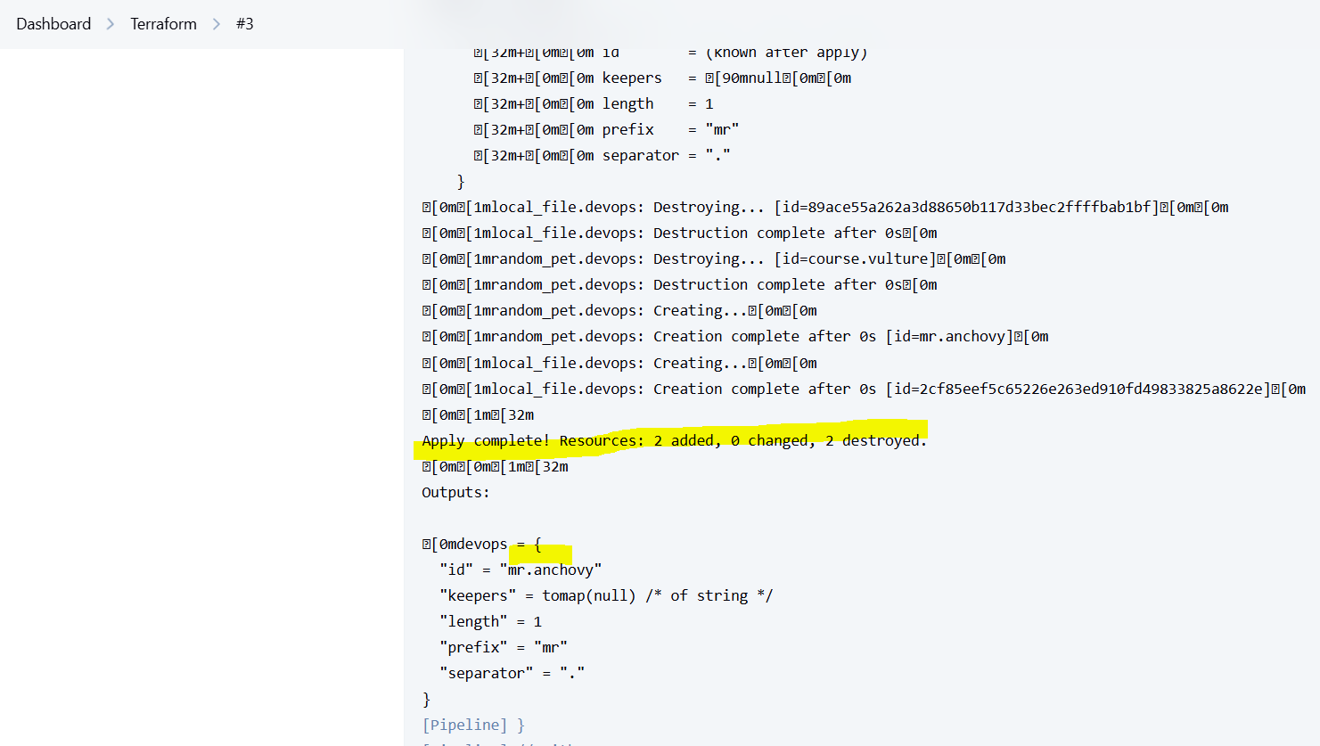

4) Create one jenkins job using MAVEN PROJECT for the below code with two stages. stage 1: Git clone stage 2: Maven Compilation Code: https://github.com/betawins/java-Working-app.git

Create a Freestyle job.
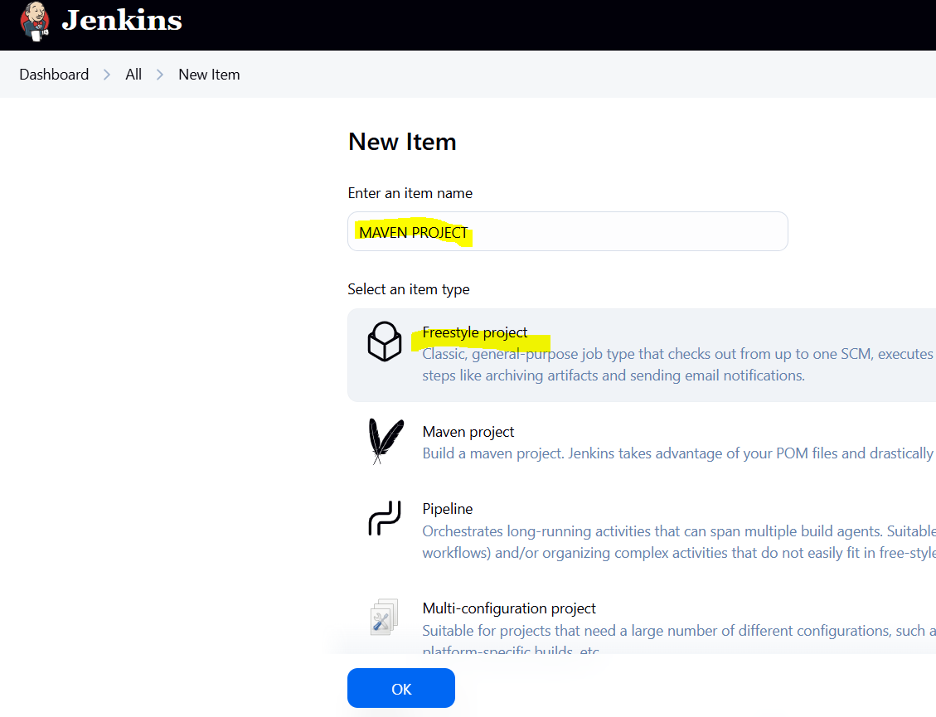

Add the git URL in SCM.
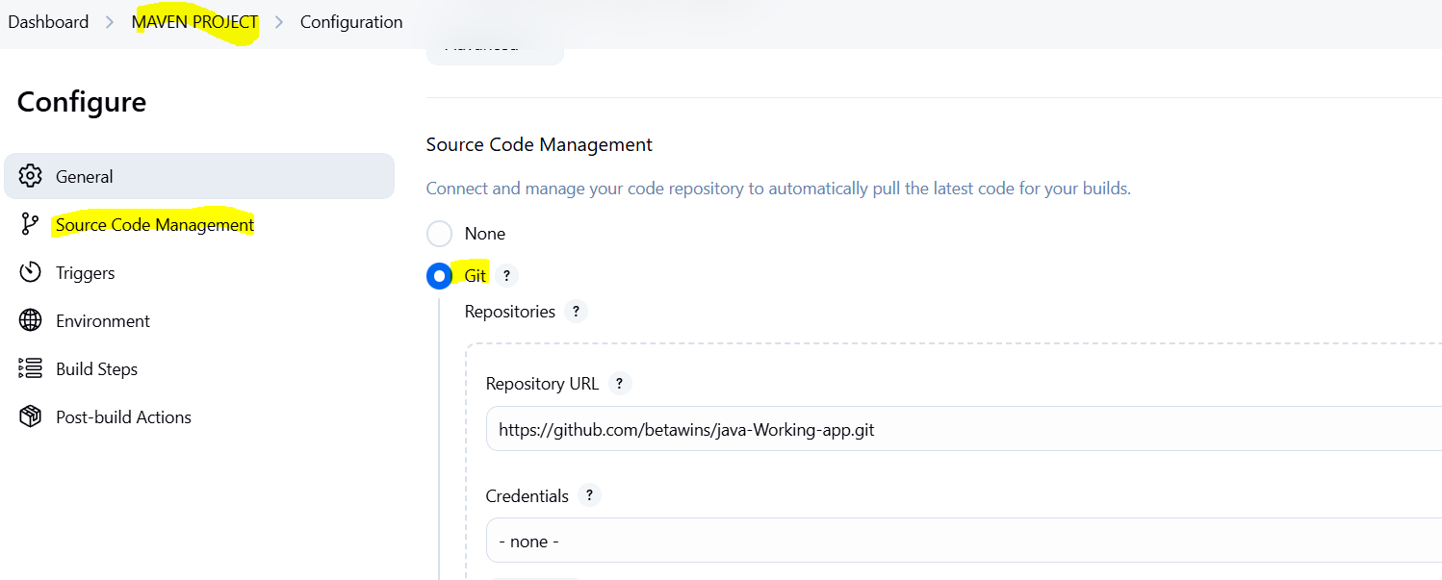
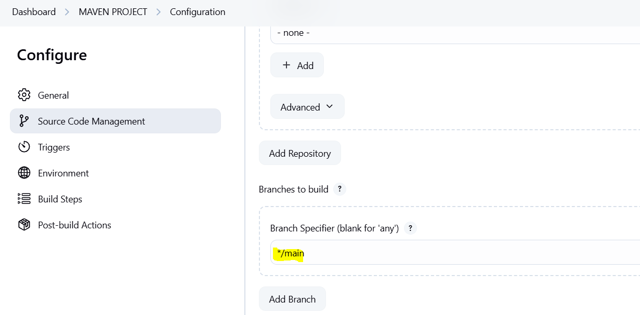

Configure maven in Built-steps.
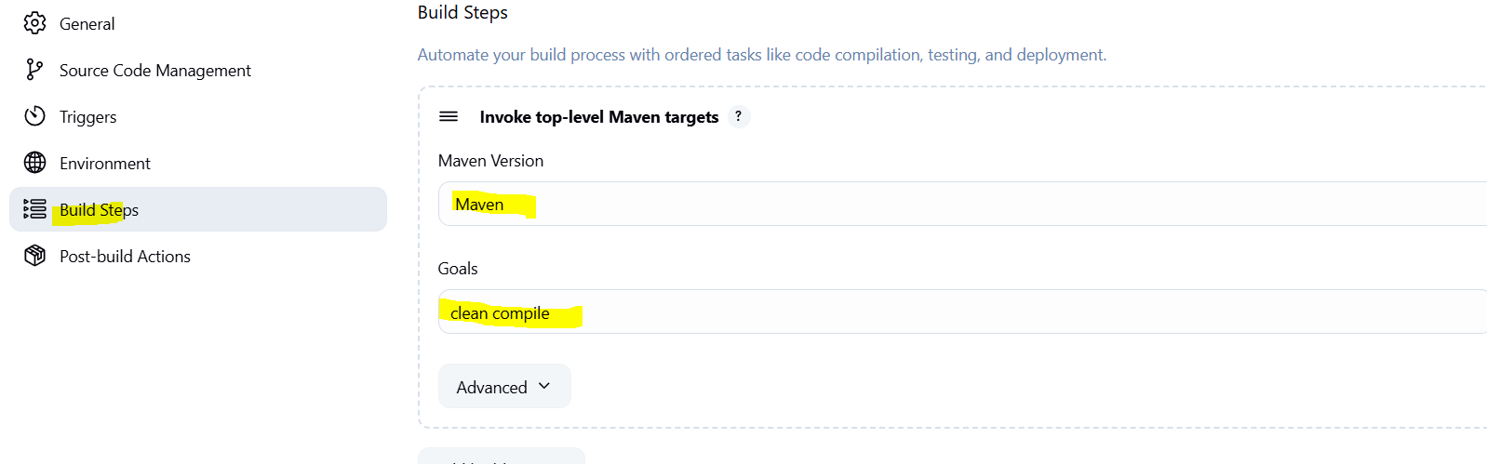

Save and click on Build Now.
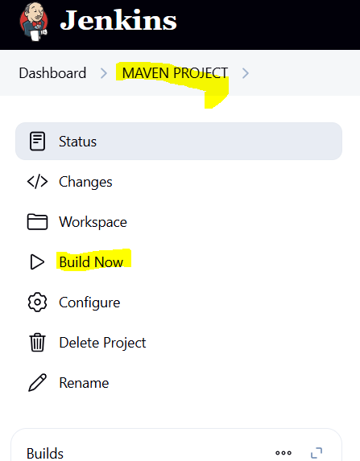

stage 1: Git clone

stage 2: Maven Compilation

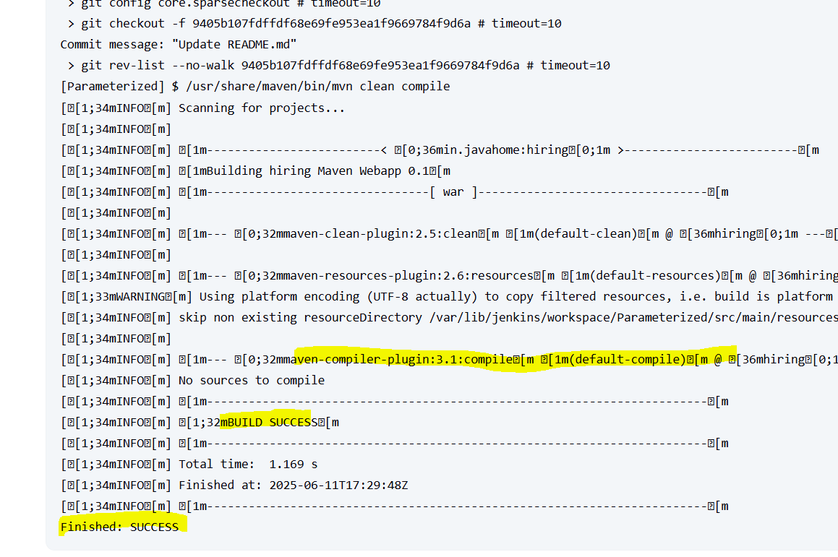

5) Use the below code and create a parameterized job in jenkins stage 1: Git clone stage 2: Maven Compilation Code: https://github.com/betawins/java-Working-app.git

Create a Freestyle job.
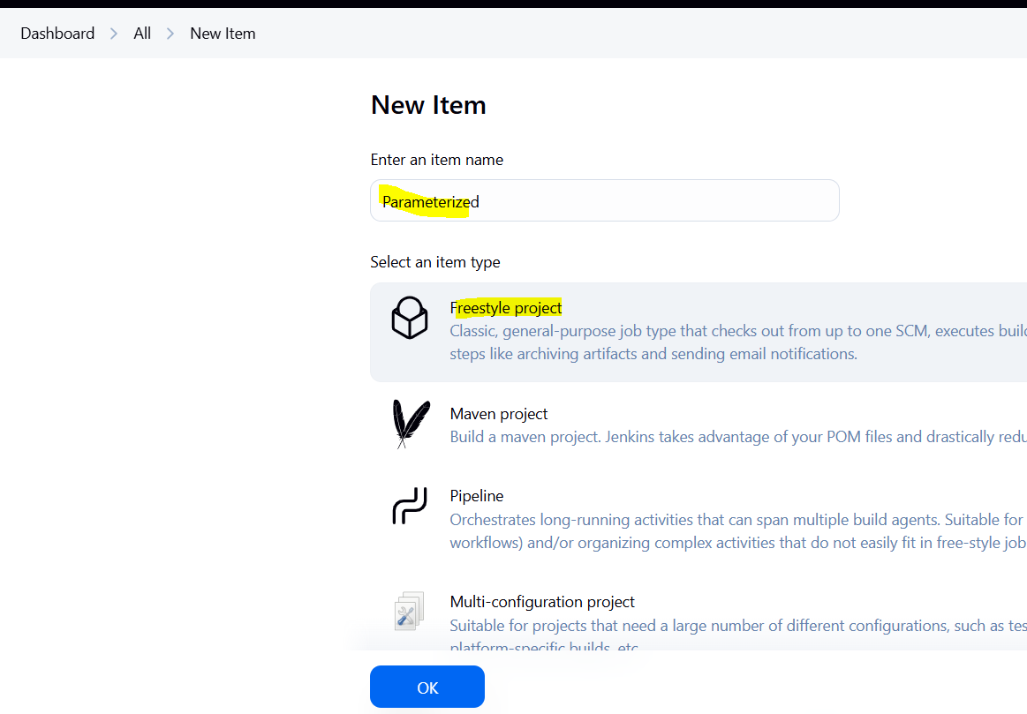

Configure parameters for the job.

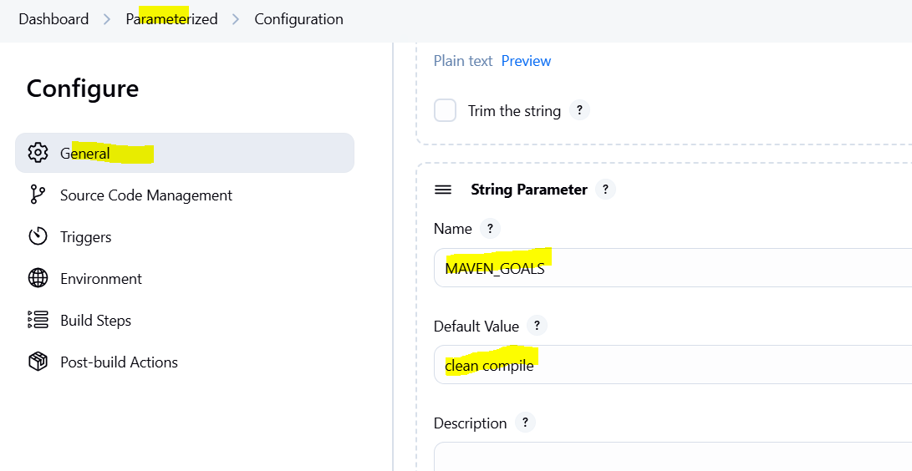
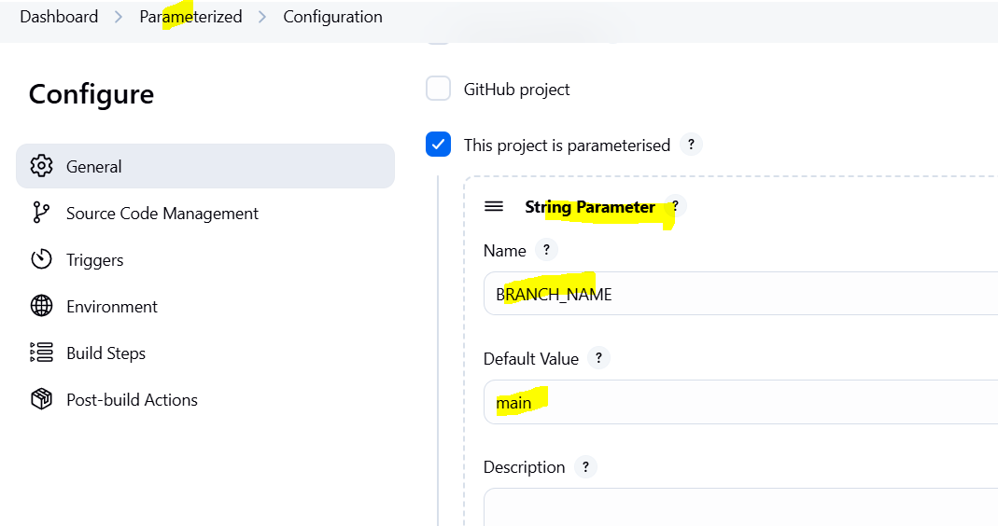

Add the git URL in SCM and configuring variable at branch to be parameterized.
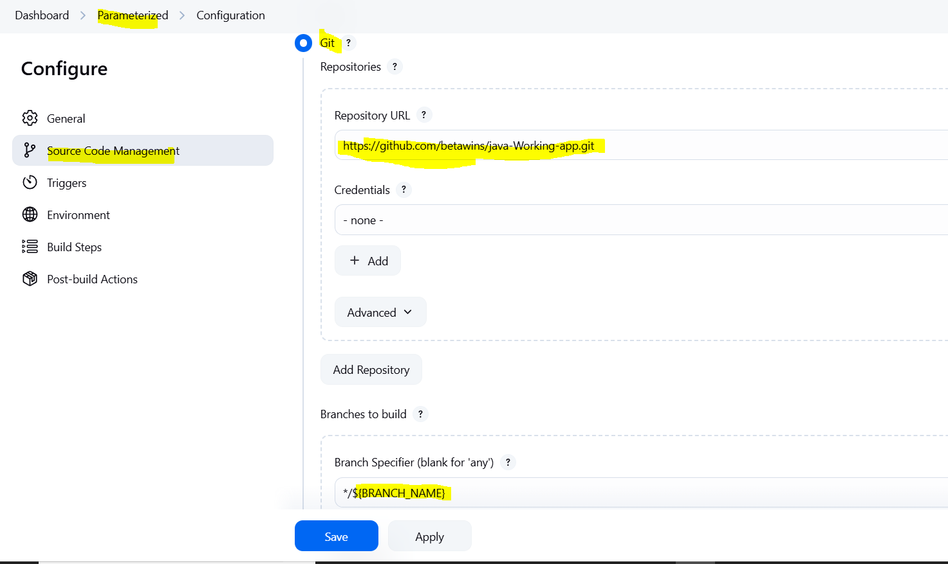

Configure maven in Built-steps and configuring variable at goals to be parameterized.
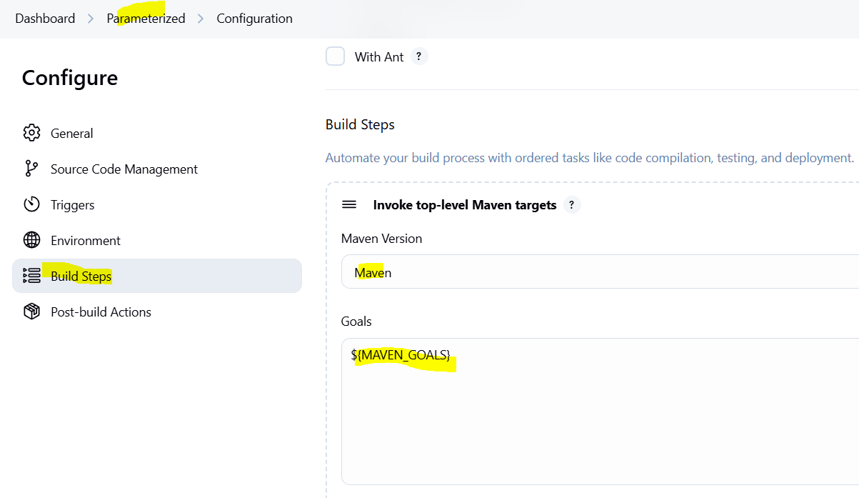

Save and click on Build with Parameters.
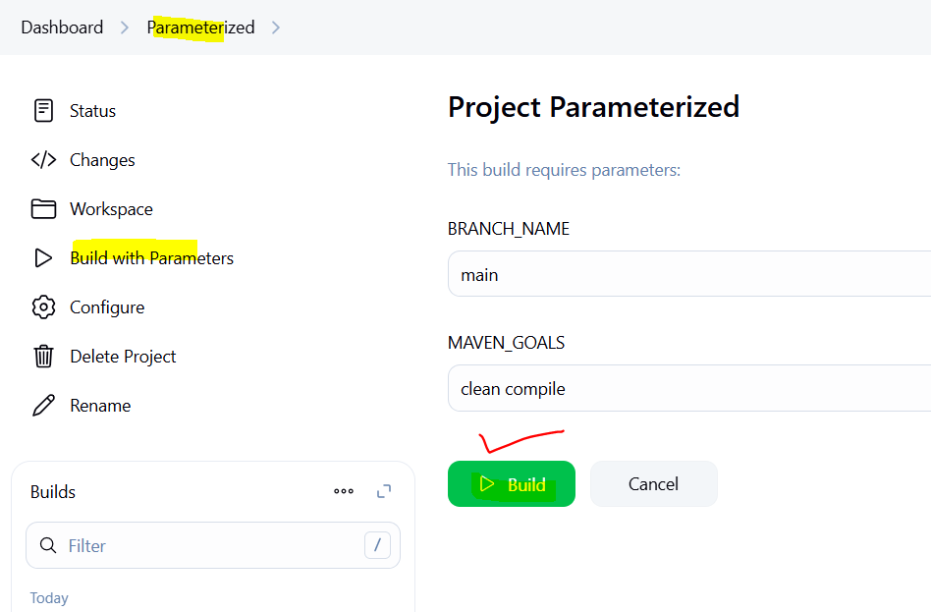

stage 1: Git clone

stage 2: Maven Compilation

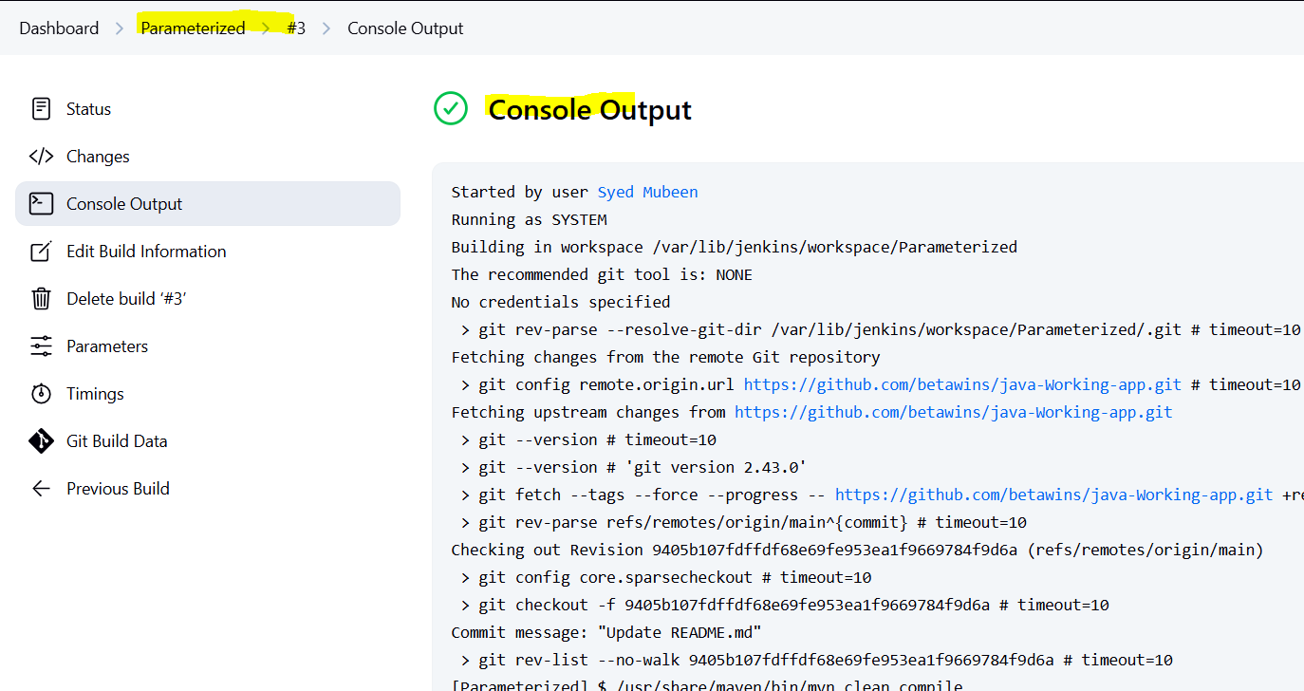

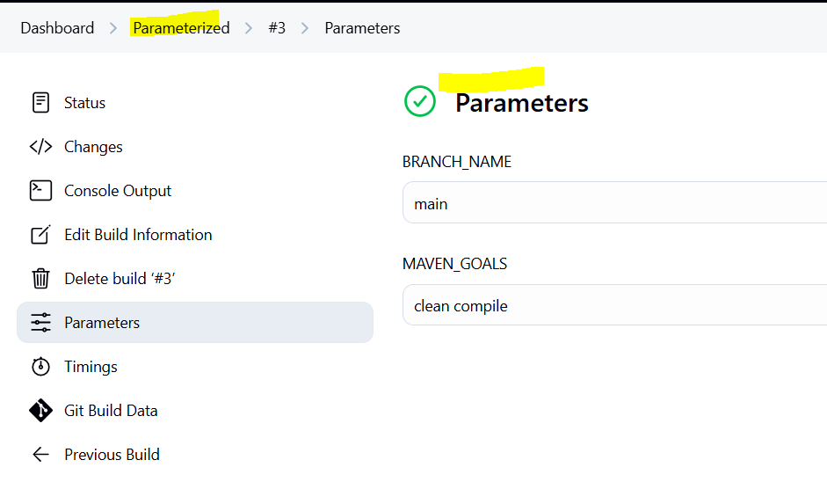

6) What are the global varaiables in jenkins?
1. BUILD_NUMBER – Represents the current build number. Used to tag or version builds uniquely.
2. BUILD_ID – Gives the build's timestamp-based ID. Helpful for tracking when a build occurred.
3. BUILD_URL – The full URL to the current build. Useful in notifications or logging.
4. JOB_NAME – The name of the Jenkins job. Used for referencing the job in logs or scripts.
5. JOB_BASE_NAME – Just the short name of the job without folder paths. Helps when jobs are inside folders.
6. WORKSPACE – The file path on disk where Jenkins checks out and builds your code. Useful for scripts and file management.
7. EXECUTOR_NUMBER – Shows which executor (worker thread) ran the job. Useful in parallel builds.
8. NODE_NAME – The name of the node (agent) running the job. Used in multi-node configurations.
9. NODE_LABELS – Labels associated with the node. Helps Jenkins decide where to run the job based on label matching.
10. JENKINS_HOME – Path to Jenkins’s root directory on the controller. Important for internal Jenkins data storage.
11. BUILD_TAG – A unique tag combining job name and build number. Useful for tagging artifacts or logs.
12. HUDSON_URL – Legacy variable for Jenkins base URL (used in older plugins). Same as JENKINS_URL.
13. JENKINS_URL – The root URL of your Jenkins server. Important for building webhooks or scripts.
14. URL – Alias to JENKINS_URL, also represents the Jenkins root.

Git-related Environment Variables (auto-injected when using Git SCM):
15. GIT_COMMIT – The commit hash being built. Useful for version control and traceability.
16. GIT_PREVIOUS_COMMIT – The previous commit hash before the current one. Useful for comparison or changelogs.
17. GIT_BRANCH – The branch name Jenkins checked out. Useful in multi-branch jobs or conditionally handling builds.
18. GIT_URL – The Git repository’s URL. Helpful for documentation and linking back.
19. GIT_AUTHOR_NAME – Author of the latest commit. Good for notifications or logs.
20. GIT_AUTHOR_EMAIL – Email address of the latest commit author. Often used in commit-based notifications.
21. GIT_COMMITTER_NAME – Name of the person who committed the change. Different from the author in some cases.
22. GIT_COMMITTER_EMAIL – Email address of the committer.

Trigger-related Variables:
23. CAUSE – General reason why the build was triggered (manual, SCM, upstream, etc.).
24. CAUSE_MANUALTRIGGER – Set if a user manually triggered the build.
25. CAUSE_UPSTREAMTRIGGER – Set if this build was triggered by another job.

Tool-based Variables (when using Jenkins tools like Maven, JDK):
26. JAVA_HOME – Path to the configured JDK. Required for Java builds.
27. M2_HOME – Path to the configured Maven installation. Used in Maven projects.
28. PATH+MAVEN – Adds Maven to the system path so mvn command works anywhere.

Pipeline Environment Variables (used in scripted and declarative pipelines):
29. env.BUILD_NUMBER – Access to environment variables using env object. Good for reusable pipeline logic.
30. params.PARAM_NAME – Access to job parameters using params. Essential in parameterized builds.
31. currentBuild – Reference to the current build object. Lets you access result, duration, cause, etc.
32. scm – Refers to the source control configuration. Used when triggering checkouts manually.

Shared Library Variables:
33. Custom functions in vars/ – Reusable Groovy functions that can be accessed globally across all pipelines.
34. Classes in src/ – Groovy/Java utility classes used for advanced shared logic.

Credentials (when injected using Credentials Plugin):
35. USERNAME / PASSWORD / TOKEN – Secure variables injected into environment for use in scripts or integrations.

Custom Global Environment Variables (user-defined):
36. Any variable you define manually – You can define global env variables in Manage Jenkins → Configure System → Global properties. For example:
ENV = dev → used to differentiate between environments in jobs.

THE-END

